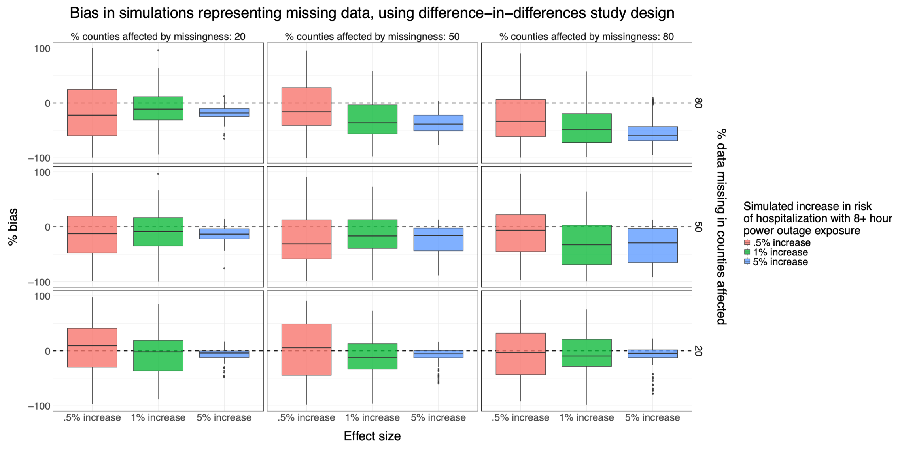

**Figure 4**: Results from simulations of the association between power outage exposure and hospitalizations in 100 counties with different percentages of exposure data missing for a difference-in-differences design. Simulations were repeated 100 times, and boxplots show the distribution of the percent bias of effect estimates in each simulation scenario. There is a dashed line at 0. Results correspond to **Table 2**.